Notes Page 2 Characteristics of Animals

“Root Words” to look for… multi, eu, hetero, a, bi, ab, morph, meta, cephalo,

- In addition to being multicellular (made of many cells) , eukaryotic (made of cells with nuclei) and heterotrophic (have to eat other things to get food) they may show symmetry (arrangement of body parts around an axis)
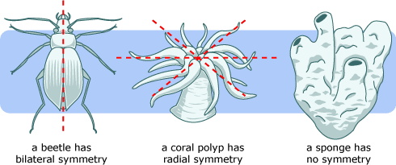
Asymmetrical – no symmetry (sponges)
Radial Symmetry – symmetry in the shape of a wheel; body parts arranged in a circle around a center axis (cnidarians, echinoderms) **no head!!!
Bilateral Symmetry – symmetry in which there is a right and left side that are mirror images and anterior (head) and posterior (tail) end (worms, arthropods, and all vertebrates)

- May Show Cephalization (have a head) Sensory organs concentrated at the head end of the organism. Always have bilateral symmetry (worms, arthropods, vertebrates) Nervous System may be a true brain and nerves, smaller mini-brains called ganglia, or a nerve net.

- May Show Segmentation Only present in more complex animals. Repetition of body parts and/or a body divided into compartments.

- Most Have a Body Cavity Coelom – true body cavity fully. (a hollow space where body processes happen) The digestive tube may have only one opening (gastrovascular cavity) or digestive tract (two opening, entrance and exit) The respiratory system may be gills, lungs, or just the “skin”. The circulatory system may be open or enclosed within tubes than run throughout the body.

- Body Surfaces:

Anterior – toward the head
Posterior – toward the anus
Dorsal – toward the spine (back)
Ventral – toward the stomach (belly button)
Lateral – to the side
Oral – side where the mouth is located
Aboral – side opposite where the mouth is located

- May have asexual and/or sexual reproduction. Also as a species may be hermaphroditic (both male and female at the same time/ produce both sperm and egg) or dioecious (either male or female form) May have Larval Forms: Some animals go through immature LARVAL forms that do NOT resemble the adult such as a Planula (larva of cnidarians such as jellyfish, corals, & sea anemones) or a Trochophore – larva of mollusks (squids & octopus)

- May undergo Metamorphosis: complete or incomplete. An idea common in ARTHROPODS
Incomplete (egg nymph adult) Complete (egg larva pupa adult)

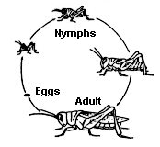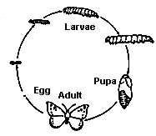

- Support Systems: Whereas vertebrates have real bones for support, invertebrates have other means… Sponges are the simplest animals supported by spongin (protein) and spicules. Limestone Cases support coral polyps (animals) “Worms” have fluid-filled body cavities making a hydrostatic skeleton. Arthropods have outside exoskeletons. Echinoderms (star fish) & vertebrates have internal bone-like pieces.

Words to Know…”all position terms”, symmetry, cephalization, segmentation, coelom, hermaphroditic, dioecious, larval, spicules, hydrostatic, exoskeleton, gastrovascular, ganglia

